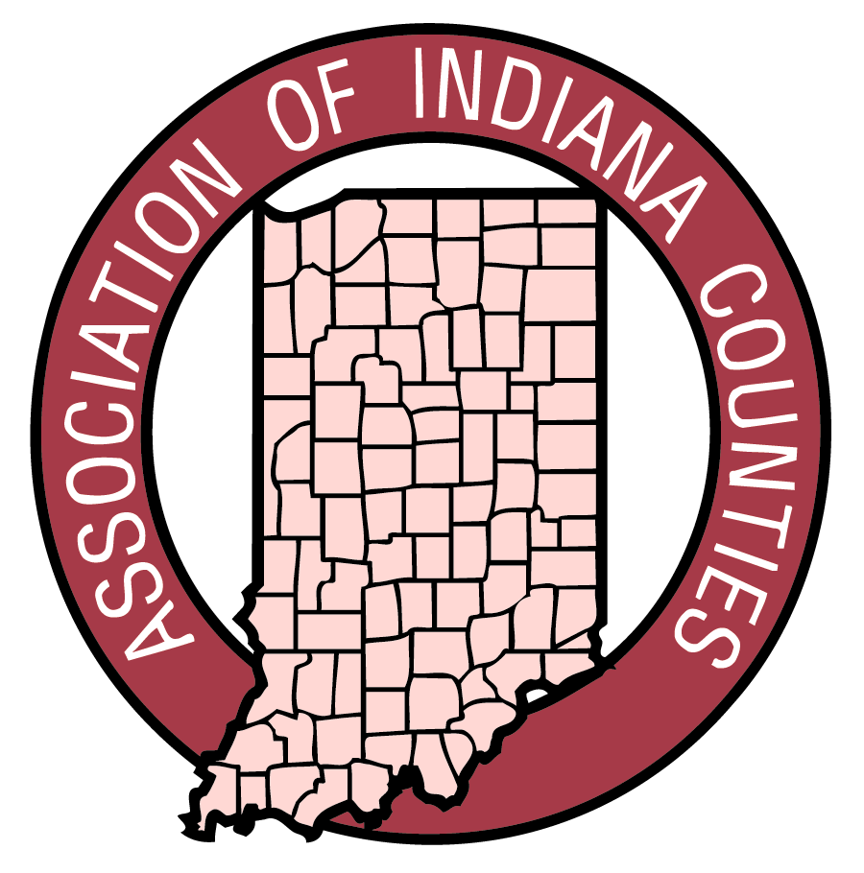
CONTACT:
Karen Avery
(317) 684-3710
kavery@indianacounties.org
www.indianacounties.org

FOR IMMEDIATE RELEASE
October 16, 2009

Ongoing Education Program Awards (Hostetler) Government DIPLOMA Certificate

The Association of Indiana Counties (AIC) is pleased to announce that (Huntington County, Superintendent, Troy Hostetler) has received an AIC DIPLOMA Certificate.
With the many facets and complexities of government, well-educated people are needed to insure that government functions run smoothly. The AIC has devoted its resources to improve government through its educational program called DIPLOMA (Development Improvement & Preparation for Leadership Organizational & Management Achievement). The DIPLOMA Program was established in 1993 to allow officials and county employees access to training which is geared specifically to county government.
The DIPLOMA Program is made available to all elected county officials and staff. After accruing thirty credit hours of study within two consecutive years, program participants qualify for DIPLOMA Certification. Participants are also encouraged to continue the learning process after DIPLOMA Certification is achieved. Continuing education credits are also available through this program.

The Association of Indiana Counties, Inc. is a nonprofit organization established in 1957 for the betterment of county government. The various functions of the AIC include lobbying the Indiana General Assembly on behalf of counties, serving as liaison among counties, state and federal agencies as well as providing technical assistance and training to county officials and employees.

###

